
FACULTY OF ENGINEERING AND TECHNOLOGY
DEPARTMENT OF WATER RESOURCES ENGINEERING
GROUP 16 WAR
S/N | NAMES | REG.NO
 | AWIDI VANESSA | BU/UP/2025/1536
 | OLINGA JONATHAN | BU/UP/2025/1562
 | AUMA PRETTY | BU/UP/2025/2109
 | CHEMONGES RONNEY | BU/UP/2025/2112
 | ORIOKOT ABRAHAM | BU/UG/2025/0014

SECANT METHOD
Qn. Find the roots of the function f(x) = x^5 + x^3 + 3 using secant method .get solutions for "for" and "while "loop. Draw a flowchart and get a pseudo code.
Matlab code
clc; clear; close all;
f = @(x) x^5 + x^3 + 3;
x0 = -2;
x1 = -1;
tol = 0.0001;
maxIter = 100;
iter = 0;

fprintf('SECANT METHOD - WHILE LOOP\n');
fprintf('f(x) = x^5 + x^3 + 3\n\n');
fprintf('Iter\t x2\t\t\t f(x2)\n');
fprintf('----------------------------------------\n');
while iter < maxIter
iter = iter + 1;
f0 = f(x0);
f1 = f(x1);
x2 = x1 - f1*(x1 - x0)/(f1 - f0);
fprintf('%d\t %.10f\t %.10f\n', iter, x2, f(x2));

if abs(x2 - x1) < tol
fprintf('\nROOT FOUND = %.6f after %d iterations\n', x2, iter);
break;
end
x0 = x1;
x1 = x2;
end

SECANT METHOD - WHILE LOOP
f(x) = x^5 + x^3 + 3

Iter x2 f(x2)
----------------------------------------
1 -1.0263157895 0.7802680370
2 -1.1197631383 -0.1645157697
3 -1.1034910955 0.0200577616
4 -1.1052593922 0.0004356633
5 -1.1052986531 -0.0000011919

ROOT FOUND = -1.105299 after 5 iterations
fprintf('SECANT METHOD - FOR LOOP\n');
fprintf('f(x) = x^5 + x^3 + 3\n\n');
fprintf('Iter\t x2\t\t\t f(x2)\n');
fprintf('----------------------------------------\n');

for i = 1:maxIter
f0 = f(x0);
f1 = f(x1);
x2 = x1 - f1*(x1 - x0)/(f1 - f0);
fprintf('%d\t %.10f\t %.10f\n', i, x2, f(x2));

if abs(x2 - x1) < tol
fprintf('\nROOT FOUND = %.6f after %d iterations\n', x2, i);
break;
end
x0 = x1;
x1 = x2;
end
SECANT METHOD - FOR LOOP
f(x) = x^5 + x^3 + 3

Iter x2 f(x2)
----------------------------------------
1 -1.1052986531 -0.0000011919

ROOT FOUND = -1.105299 after 1 iterations
Pseudocode
START
DEFINE f(x) = x^5 + x^3 + 3
INPUT x0 = -2, x1 = -1, tol = 0.0001, maxIter = 100
FOR i = 1 to maxIter
f0 = f(x0), f1 = f(x1)
x2 = x1 - f1*(x1-x0)/(f1-f0)
IF |x2 - x1| < tol THEN
PRINT "Root = x2"
STOP
END IF
x0 = x1
x1 = x2
END FOR
PRINT "Not Converged"
END

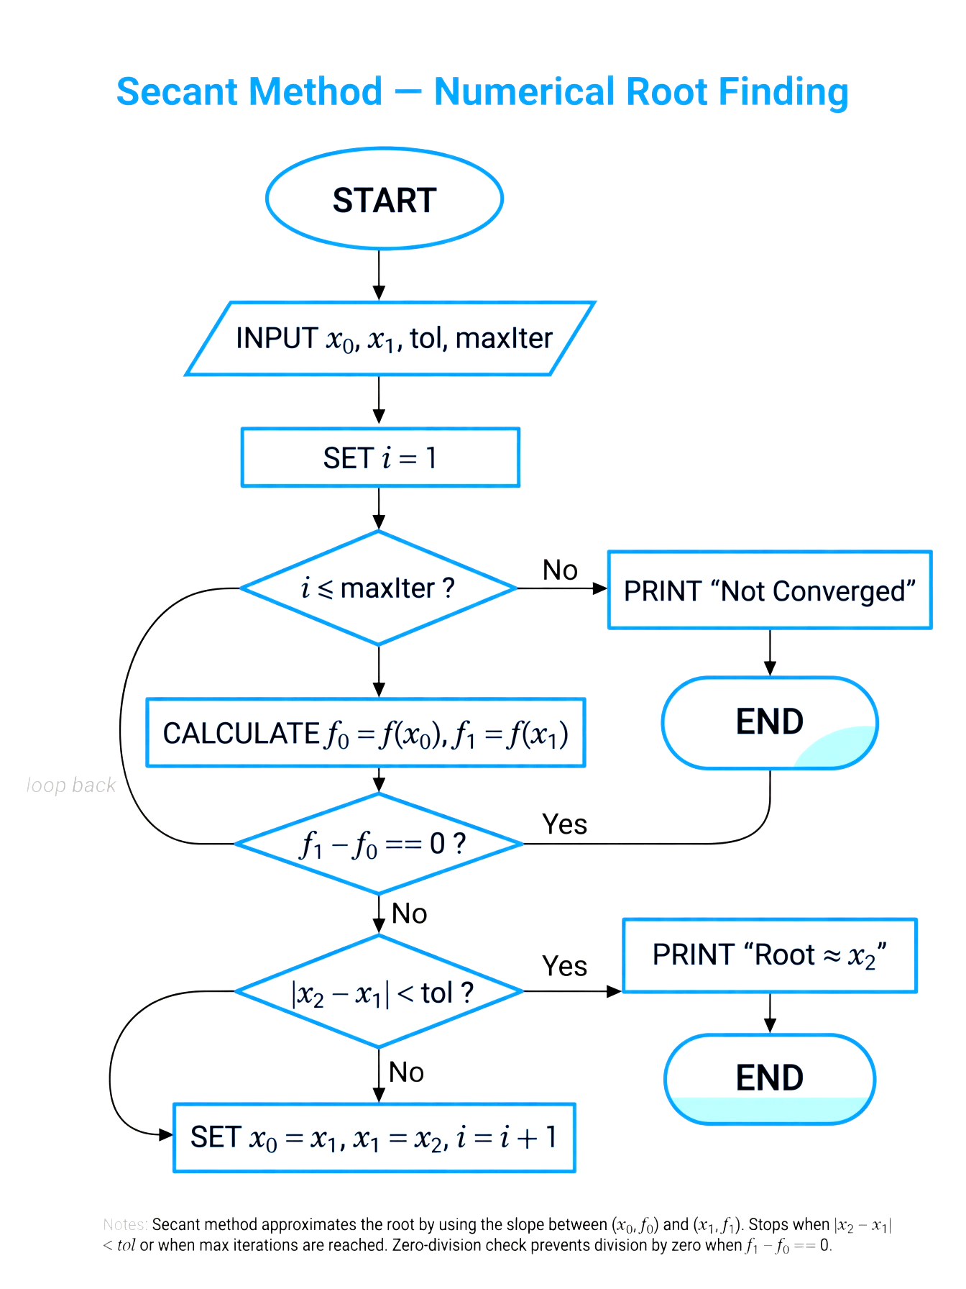
NEWTON RAPSHON METHOD
clc; clear;
f = @(x) x^2 - 4;
df = @(x) 2*x;
x0 = -3;
tol = 1e-4; maxIter = 20;

fprintf('NEWTON RAPHSON - FOR LOOP\nf(x)=x^2-4\n\n');
fprintf('Iter\tx0\t\t x1\t\t f(x1)\n');
for i=1:maxIter
x1 = x0 - f(x0)/df(x0);
fprintf('%d\t%.6f\t%.10f\t%.10f\n',i,x0,x1,f(x1));
if abs(x1-x0)<tol
fprintf('\nROOT = %.6f\n',x1); break;
end
x0 = x1;
end
NEWTON RAPHSON - FOR LOOP
f(x)=x^2-4

Iter x0 x1 f(x1)
1 -3.000000 -2.1666666667 0.6944444444
2 -2.166667 -2.0064102564 0.0256821170
3 -2.006410 -2.0000102400 0.0000409602
4 -2.000010 -2.0000000000 0.0000000001

ROOT = -2.000000
f = @(x) x^2 - 4;
df = @(x) 2*x;
x0 = -3;
tol = 1e-4; maxIter = 20; iter=0;

fprintf('NEWTON RAPHSON - WHILE LOOP\nf(x)=x^2-4\n\n');
while iter<maxIter
iter=iter+1;
x1 = x0 - f(x0)/df(x0);
fprintf('%d\t%.6f\t%.10f\n',iter,x1,f(x1));
if abs(x1-x0)<tol
fprintf('\nROOT = %.6f\n',x1); break;
end
x0 = x1;
end
NEWTON RAPHSON - WHILE LOOP
f(x)=x^2-4

1 -2.166667 0.6944444444
2 -2.006410 0.0256821170
3 -2.000010 0.0000409602
4 -2.000000 0.0000000001

ROOT = -2.000000
PSEUDOCODE
START
DEFINE f(x)=x^2-4, df(x)=2x
INPUT x0, tol=0.0001, maxIter=100
FOR i=1 to maxIter (or WHILE)
f0 = f(x0), df0 = df(x0)
IF df0==0 THEN PRINT "Derivative zero" STOP
x1 = x0 - f0/df0
IF |x1-x0| < tol THEN PRINT Root=x1 STOP
x0 = x1
END
END
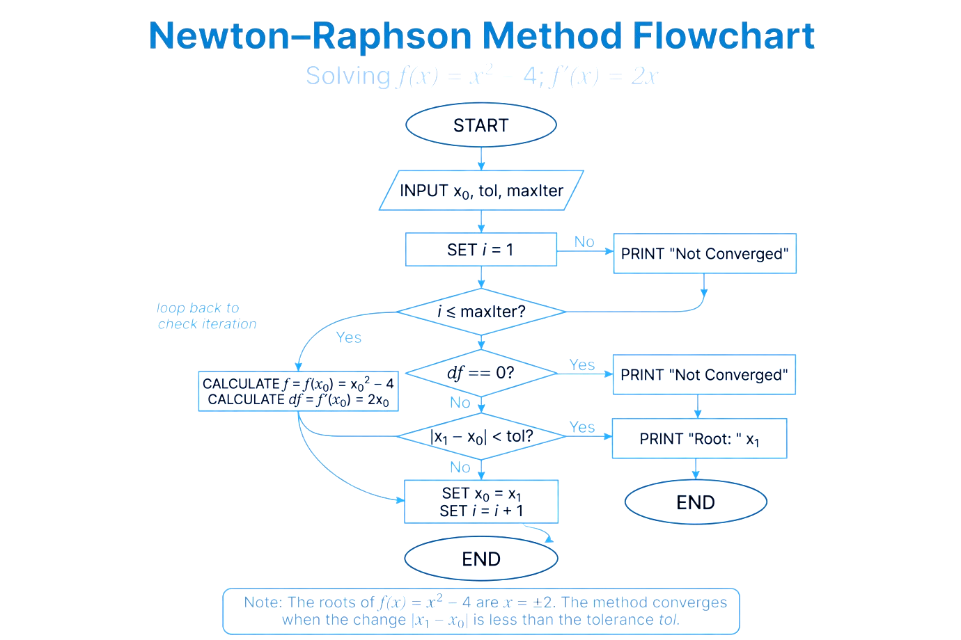

RUNGE KUTTA
clc; clear;
f = @(t,y) t^2 - y;
t0=0; y0=1; h=0.1; tn=1;
t=t0; y=y0;
n=(tn-t0)/h;

fprintf('RUNGE KUTTA - FOR LOOP\n');
fprintf('Iter\tt\ty\n');
for i=1:n
k1 = h*f(t,y);
k2 = h*f(t+h/2, y+k1/2);
k3 = h*f(t+h/2, y+k2/2);
k4 = h*f(t+h, y+k3);
y = y + (k1+2*k2+2*k3+k4)/6;
t = t + h;
fprintf('%d\t%.1f\t%.8f\n',i,t,y);
end

RUNGE KUTTA - FOR LOOP
Iter t y
1 0.1 0.90516271
2 0.2 0.82126950
3 0.3 0.74918215
4 0.4 0.68968043
5 0.5 0.64346993
6 0.6 0.61118905
7 0.7 0.59341548
8 0.8 0.59067192
9 0.9 0.60343131
10 1.0 0.63212161
f = @(t,y) t^2 - y;
t0=0; y0=1; h=0.1; tn=1;
t=t0; y=y0; iter=0;

fprintf('RUNGE KUTTA - WHILE LOOP\n');
fprintf('Iter\tt\ty\n');
while t < tn
iter=iter+1;
k1 = h*f(t,y);
k2 = h*f(t+h/2, y+k1/2);
k3 = h*f(t+h/2, y+k2/2);
k4 = h*f(t+h, y+k3);
y = y + (k1+2*k2+2*k3+k4)/6;
t = t + h;
fprintf('%d\t%.1f\t%.8f\n',iter,t,y);
end
fprintf('Final y(1)=%.6f\n',y);
RUNGE KUTTA - WHILE LOOP
Iter t y
1 0.1 0.90516271
2 0.2 0.82126950
3 0.3 0.74918215
4 0.4 0.68968043
5 0.5 0.64346993
6 0.6 0.61118905
7 0.7 0.59341548
8 0.8 0.59067192
9 0.9 0.60343131
10 1.0 0.63212161
11 1.1 0.67713005
Final y(1)=0.677130
